Change Zoom profile picture:

- You have to have a Zoom account.
- Log into the account and then go to PROFILE in the menu on your left. It is under PERSONAL

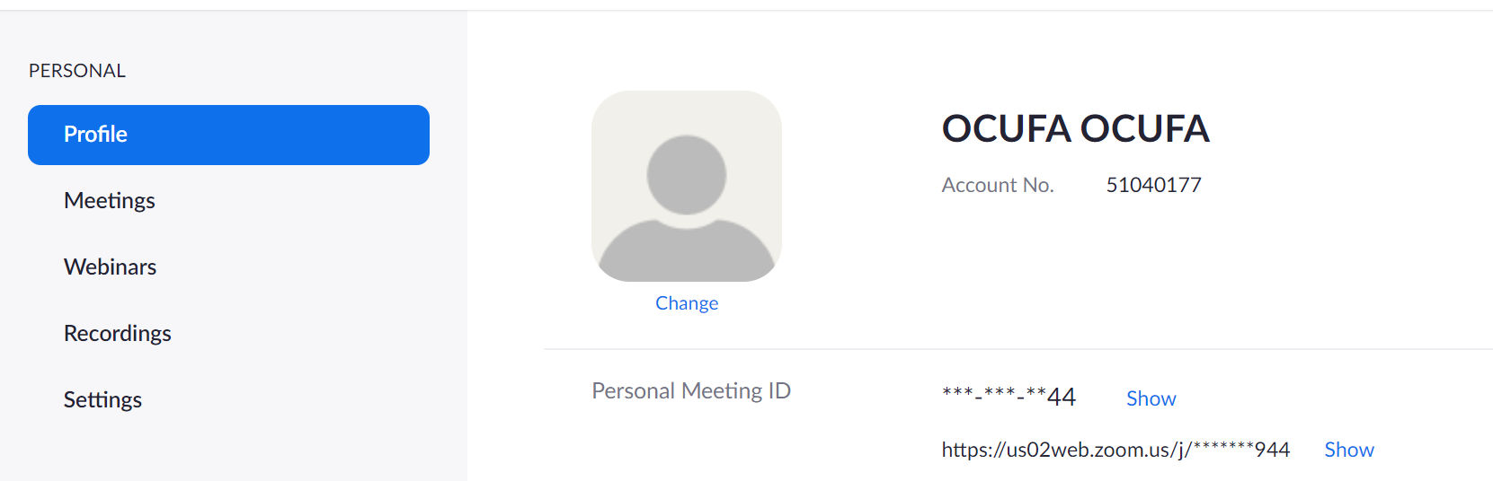

- Under the grey person icon, click on Change
- Click on Upload and select a phone you want to use. Move it around and crop it to the size you’d like. The grey part is not going to be shown, and only the white part will be the profile picture. The preview is on the right. Drag the corner of the dotted box to change the size of the selection.
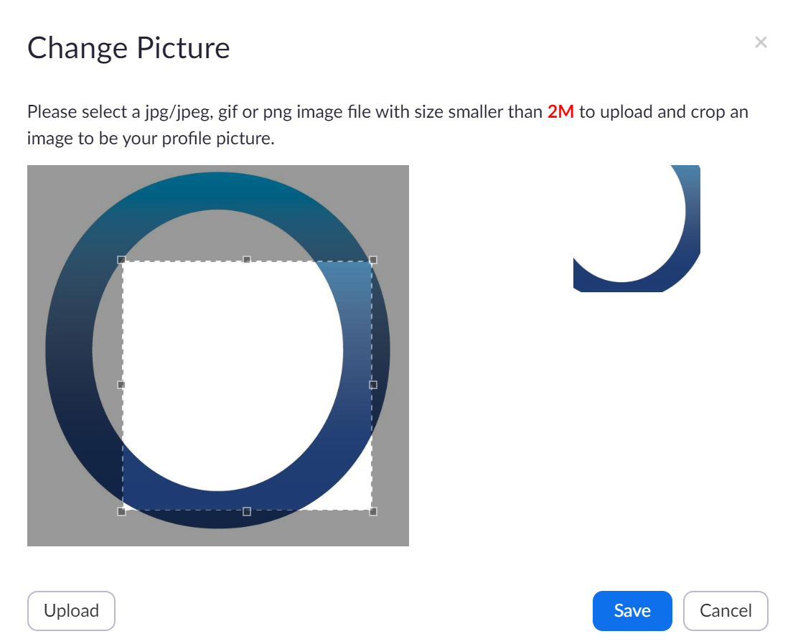
- Click on Save.
Later on when you join any zoom meeting with this logged in account, and not having video enabled, you will have this picture showing.

